A Guide to Developing a Theory of Change: Part I

To make this guide easier to use, it is provided in two parts:
Part I: Provides an overview of the three essential building blocks of a good theory of change: 1) the root cause of a problem, 2) the desired outcome, and 3) the pathway of change (causal links) necessary to move from the problem to achieving the outcome.
Part II: Provides an overview of the final pieces of a full theory of change: Indicators and Assumptions
Much of this guide was developed using the Development, Implementation and Assessment Toolkit and the CQI Training Academy (both projects of the Children’s Bureau). Please go to the following links and watch the tutorials provided before using this guide with customers:
- CQI Training Academy, Unit 4, Module 2: Building a Theory of Change https://caplearn.childwelfare.gov/mod/scorm/view.php?id=102
- Development, Implementation and Assessment Toolkit, Section 2: Develop a Theory of Change https://diatoolkit.childwelfare.gov/section-2
Please note, to view these tutorials you need to register for the CapLEARN system (https://caplearn.childwelfare.gov).

What is a Theory of Change?

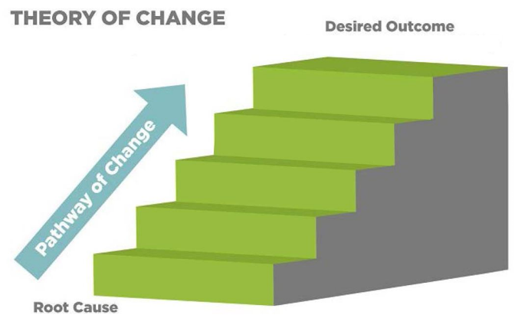
A theory of change is a theory or hypothesis that describes the root cause of the problem, the desired outcome(s), and how to reach those outcomes. It provides direction for how and why change will happen and the changes that need to occur within an agency or organization before the desired outcome can be achieved.
This tool provides an overview of the three essential building blocks of a good theory of change: 1) the root cause of a problem, 2) the desired outcome, and 3) the pathway of change (causal links) necessary to move from the problem to achieving the outcome.
When to Develop a Theory of Change?
Before moving into the discussion of the development of a theory of change, it is important to consider when it is appropriate to develop a theory of change. Below are a few guidelines for, 1) developing a theory of change when designing a new program and when to use a ToC after a program is operating.
- If you are designing a new program, initiative, or installing an intervention - Ideally, organizations begin developing a theory of change when they first start designing a new program, are considering a new change initiative, or are planning an intervention.
In this case, a theory of change should be developed BEFORE you have chosen an intervention, practice, program, or other solution to address the problem and the needs of the target population.
It should be developed AFTER you have:
- Identified the problem and the root cause of the problem
- Identified the target population and understand their needs

- If a program is already operating – Often, organizations develop theories of change after their programs or initiatives are already operating. If you are in this situation, developing a Theory of Change is still a valuable activity that can help you:
- Validate your program’s goal/outcome and logic
- Challenge assumptions to reveal potential program adjustments to maximize success

Theory of Change vs. Logic Model
A theory of change is not a logic model, though the terms are often used interchangeably. The primary difference is that a theory of change DOES NOT REQUIRE the identification of an intervention or solution, but a logic model does. The table below summarizes the key differences.
Theory of Change | Logic Model
Solution, program or intervention HAS NOT been identified. | Solution, program or intervention HAS been identified.
Explains the causal pathway to get from the root cause to the expected outcome. | Describes the inputs, activities, outputs and expected outcomes of a program or intervention.
Can be helpful in developing indicators of each outcome to help measure progress towards achieving the desired outcome. | Doesn’t require the development/use of indicators.
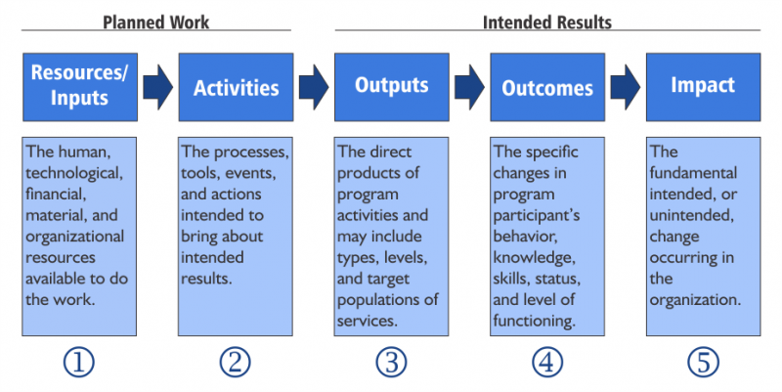
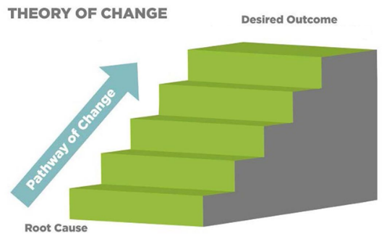

How to Develop a Theory of Change
The Center’s process for developing a theory of change is based on the process described in The Development, Implementation and Assessment Toolkit, and the CQI Training Academy. This process includes five steps. The following three are described below:
- Be sure you have a root cause with supporting data
- Identify your desired outcome(s)
- Describe the Pathway of Change (Causal Link)

- Root Cause and Target Population
After the team identifies the problem they want to address and has identified the population most at risk of experiencing the problem, the next step is to identify the root cause of the problem. This is accomplished through a process called Root Cause Analysis. A key principle of Root Cause Analysis is that the underlying causes of a problem must be understood before the problem can be addressed and a theory of change can be developed.
If you have identified your problem, target population, and root cause, and you have supporting data, move to number 2, “Desired Outcomes” below. If you need to do more work on your problem, root cause or target population, go to the following for more information:
- Development, Implementation and Assessment Toolkit: Section 1 https://diatoolkit.childwelfare.gov/section-1
- The CQI Training Academy: Unit 3, Module 2: https://caplearn.childwelfare.gov/mod/scorm/view.php?id=87
Example: Kansas Intensive Permanency Project
The example used is this document is from the Children’s Bureau funded Kansas Intensive Permanency Project (KIPP), part of the Permanency Innovations Initiative. All grantees awarded funding as a part of PII were required to develop a theory of change. The problem, target population and root cause identified by KIPP are provided in the box below. Note that the supporting research and data are not provided.
Problem to be addressed: Children in the Kansas foster care system with a serious emotional disturbance (SED) are more than 3.5 times as likely as children without an SED to experience long-term foster care. They are also 90% less likely to reunify than children without an SED.
Target Population: Children and youth, ages 3–16, who meet criteria for SED
Root Cause of Problem: Foster care contractors not delivering meaningful, intensive, home-based services and concrete supports to birth or permanency parents.

- Desired Outcomes
Key to developing a theory of change is identifying the desired outcome(s) based on the root cause of the identified problem and the needs and characteristics of the target population. In a theory of change, outcomes represent changes in conditions of some kind among people, institutions, and systems. For example, an outcome could be a change in a policy, law, behavior, attitude, knowledge, or state of the environment. Desired outcomes should be realistically achievable, and everyone involved should be able to understand them.
Example: Kansas Intensive Permanency Project
Desired Outcome – A decrease in long-term foster care for children and youth ages 3 – 16 meeting SED criteria.

- Causal Links
A theory of change includes a series of steps that have to unfold for the desired outcomes to be met. Only steps that can be linked in a way that show a causal progression toward a desired outcome should be included. Together, these steps—“causal links” — make up the pathway of change, from understanding the root cause of the problem to achieving the desired outcome.
This work can be done in three steps:
- To develop causal links, you can begin with either the outcome or the root cause. The goal is to brainstorm the pathway of changes that need to happen in order to address the root cause. Use the research and data mining involved with identifying the problem and understanding the root causes to help with this step.
- Once the team has identified a series of causal links, the links should be confirmed using “why” questions.
- Each of the causal links should be justified using data (rather than anecdotal evidence or opinions) to ensure that the theory of change is valid.
It is important to note that an initiative may have multiple pathways leading to the long-term outcome. For now, we are focusing on one outcome and one pathway. The example below provides additional information about identifying causal links for a theory of change with one pathway.

Example: Kansas Intensive Permanency Project
For example, KIPP had to determine the causal pathway to get from the root cause:
- Foster care contractors not delivering meaningful, intensive, home-based services and concrete supports to birth or permanency parents.
To the outcome:
- A decrease in long-term foster care for children and youth ages 3 – 16 meeting SED criteria.

Desired Outcome: A decrease in long-term foster care for children and youth ages 3 – 16 meeting SED criteria.

5. Because: These changes lead to more timely and stable reunifications.

- Why the focus on readiness for reunification?
4. Because: These changes combine to create readiness for family reunification.

- Why is it important for a child’s functioning to increase and behavioral problems to decrease?
Causal Pathway
3. Because: When the family’s interpersonal and social environment is bolstered, child functioning increases and behavior problems decrease.

- Why is it important to strengthen parenting and community connections and create a more adequate and pro-social environment for children?
2. Because: When parenting and community connections are strengthened, a more adequate and pro-social environment for children is created.

    - Why should resources be dedicated to improve ineffective parenting practices?
- Resources must be dedicated to improve ineffective parenting practices and to connect parents with community resources and social supports, such as mental health and substance abuse treatment.

Root Cause of Problem: Foster care contractors not delivering meaningful, intensive, home-based services and concrete supports to birth or permanency parents.
Problem: Children in the Kansas foster care system with a serious emotional disturbance (SED) are more than 3.5 times as likely as children without an SED to experience long-term foster care. They are also 90% less likely to reunify than children without an SED.

https://diatoolkit.childwelfare.gov/
https://caplearn.childwelfare.gov/course/view.php?id=2
Add link
Add link

