

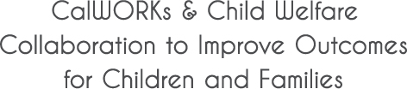

Congue nihil imperdiet doming id quod mazim placerat facer minim veni am ut wisi enim ad minimeniam, quis erat nostr uexe

rci tation ullamcorper nostru exerci tation ullam corper et iusto odio dig nissim qui blandit praesent lupta. Tummer delenit

augue duis dolore te feugait nulla facilisi. Con erattis sectetuer adip iscing elit, sed erat diam nonummy nibh magna erat.



Linkages is a dynamic and effective approach to better serving children and families. Learn more about how you can help families in your community!

Visit [www.cfpic.org](http://www.cfpic.org) for online access to videos and communication materials:

* Linkages Videos – Powerful videos that feature families who have been helped through Linkages.
* Collaboration Checklist – What Directors, Managers and Staff Can Do to Promote Collaboration.
* PowerPoint Presentations – About Linkages   
  and the importance of program collaboration   
  for families.
* Much more!

*Linkages is a project of the Child and Family Policy Institute of California and funded by the California Department of Social Services.*

Learn More!

**Effective.**

* ***For Families*** – Helps families become self-sufficient and children to have safe, stable lives.
* ***For Programs*** – Increases employment and helps to reduce child maltreatment.

**Efficient.**

* ***Leverages resources*** – Enables programs to use strengths and resources in ways that better serve families.
* ***Reduces duplication*** – Streamlines services and reduces service referrals.
* ***Creates a team approach*** – Provides more people to solve problems!

**Essential.**

* ***Success is connected*** – Serves families who are clients of both CalWORKs and Child Welfare programs, and enables treatment of family issues that impact   
  well-being in other areas.
* ***Work smarter*** – Saves time and money by addressing problems before they repeat themselves and uses available resources to treat underlying issues.
* ***Critical in tight budget times*** –Maximizes every dollar!

www.cfpic.org

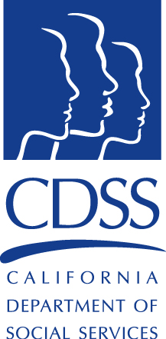

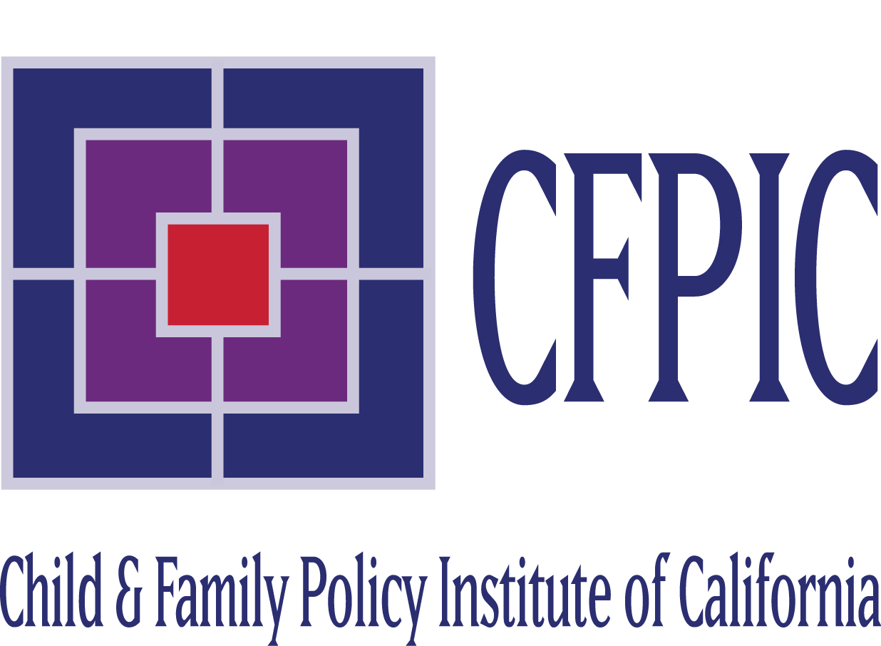





***What Staff Are Saying***

“Our ultimate goal is to help the families…because we know that outcomes for children are not good when they grow up   
in foster care.”  *– Child Welfare Staff, Los Angeles County*

“Our work participation rate is so important, so when you have a family that may not have been participating in the Welfare   
to Work program – and they are now able to participate – that helps to stop or prevent a sanction. Our numbers go up.”

*– CalWORKs Staff, Stanislaus County*

**.The Challenge**

Child Welfare Services and CalWORKs serve many of the same families, yet too often there is limited coordination, communication or resource sharing between the two programs. Parents face the complexity of negotiating multiple systems with conflicting requirements and timeframes – while counties lose the opportunity to leverage resources and provide needed supports to better serve families.

**The Solution**

Collaboration! Counties across California are coming together to implement strategies and activities to improve collaboration between CalWORKs and Child Welfare Services – collaboration that improves client services as well as the program bottom line. Children and families benefit when programs work together.

**What Linkages Is**

Linkages is an approach to social service   
work that promotes collaboration between CalWORKs and Child Welfare Services. Supported by state and federal government, Linkages got underway in California in 2000 with funding from philanthropy and is now used in more than 30 counties across the state. Our goal is to improve outcomes for children and families by providing needed services and supports through improved program collaboration.

**Linkages Strategies**

* Identifying mutual cases.
* Coordinated case planning.
* Including CalWORKs staff at Child Welfare Team Decision Meetings and Family Group Conferencing.
* Co-locating CalWORKs and Child Welfare staff.
* Creating Linkages Teams to handle mutual cases.
* Joint Case Reviews.
* Joint Fiscal Plans.
* Joint and Cross Trainings.

**TO CalWORKS & Welfare to Work Programs**

* Promotes employment and prevents CalWORKs sanctions.
* Provides Child Welfare expertise to help address families’ multiple needs.

**To Child Welfare Programs**

* Provides additional resources for helping families and improving outcomes.
* Helps reduce poverty and stressors contributing   
  to child maltreatment.

**TO BOTH PROGRAMS**

* Coordinates and streamlines services.
* Creates a team approach to helping families.

*Linkages benefits everyone! Children and families do better when they receive the support they need,   
and programs benefit when they can meet important targets and goals.*

*“I felt like I had someone on my side… It felt good not to be alone anymore in the battle that I had ahead of me.” — Parent*