County-based Medi-Cal Administrative Activities (CMAA) Program Overview

Table of Contents
Glossary of Terms 2
Overview 3
Resources 6

Glossary of Terms
CCUG – Comprehensive Claiming Unit Grid
CBO – Community Based Organizations
CPE – Certified Public Expenditure
CUFG - Claiming Unit Functions Grid
DHCS – Department of Health Care Services (State pass-through agency for federal funds)
FFP – Federal Financial Participation (reimbursement counties receive for MAA expenditures)
LGA – Local Governmental Agency (County Name)
LPE – Local Public Entity (example: First Five)
CMAA – County-based Medi-Cal Administrative Activities Program
PPPD – Program Planning, Policy Development (Time Survey Codes 15 – 18)
SPMP – Skilled Professional Medical Personnel (ex. Nurses, therapists)

Overview
The CMAA Program builds on the partnership between the California Department of Health Care Services (DHCS) and Local Governmental Agencies (LGAs) which are usually county governments. CMAA provides partial federal reimbursement to LGAs for administrative activities that support efforts to identify and enroll eligible individuals in Medi-Cal.

Funded by the Centers for Medicare & Medicaid Services (CMS)
Started in 1995, CMAA provides Federal reimbursement for a portion of the cost of performing administrative activities that promote and maintain Medicaid program.

Federal Entitlement Program
The Department of Health Care Services (DHCS) administers CMAA through a federally approved plan. It is a federal entitlement program with no cap on reimbursements.

Available through Local Government Agencies (LGAs) - Counties
LGAs (Counties) contract with DHCS & state-wide LGA Consortium.

Purpose
The federal government reimburses activities that enhance access to healthcare within county public health systems, reduce healthcare costs, and support long-term health outcomes for at-risk populations. It is less expensive to get clients connected to primary care than using the emergency department for services.

Why Participate
Reimbursement is 100% unrestricted. LGAs are partially reimbursed for allowable expenses related to activities staff already perform.

Eligible Participants
County Departments/Divisions/Offices including:
- Behavioral Health Substance Use Services
- District Attorney – Victim Witness
- Health & Human Services Administration
- Homeless Outreach
- Probation
- Public Health
- Public Guardian
- Veterans Services

Community-Based Organizations (CBOs) under contract with LGAs including:
- Family Resource Centers
- Dial 2-1-1 Resource Referral Agencies
- Family support agencies
- Agencies on Aging
- Community Action Agencies

Local Public Entities (LPEs)
- District Hospitals
- First 5 agencies

Each county department/division/office, CBO, or LPE can be a "claiming unit". A “claiming unit” is defined as an entity that is part of an LGA, such as a public agency or private/public CBOs contracted by an LGA to perform CMAA activities.

Each LGA determines the number of claiming units participating in the CMAA program.

Participating agencies must adhere to DHCS guidelines and conduct eligible activities aligned with Medi-Cal objectives to qualify for reimbursement.

CMAA Structure

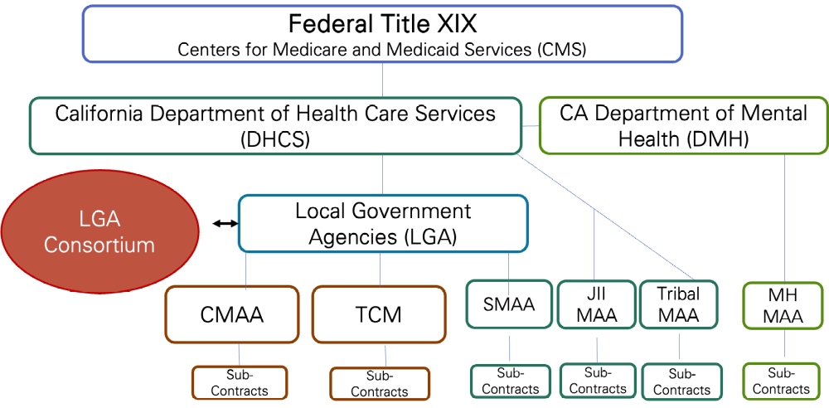

Eligible Activities
Activities eligible for reimbursement through CMAA include, but are not limited to, the following:
Activity | Description
Medi-Cal Outreach | Includes informing community members about Medi-Cal and its benefits.
Facilitating Medi-Cal Applications | Helping people complete Medi-Cal Applications and redeterminations.
Linkage to Medi-Cal Services | Referral, coordination, and monitoring activities that link people to Medi-Cal covered services.
Medi-Cal program planning | Supports program planning, policy development, and interagency coordination to ensure effective Medi-Cal service delivery.
Medi-Cal contract administration | Administration of contracts for Medi-Cal covered services.
CMAA Administration | Administering and monitoring the CMAA program.

Funding
CMAA is funded through federal Medicaid matching funds, allowing counties to recoup a portion of administrative costs associated with supporting Medi-Cal. To be eligible for reimbursement, the allowable administrative costs must be directly related to the Medi-Cal State Plan and must be found necessary for the proper and efficient administration of the Medi-Cal State Plan.

Each claiming unit is required to submit quarterly invoices detailing certified public expenditures for CMAA activities. DHCS reviews claims to ensure compliance before issuing reimbursements.

Resources
Webpages
DHCS CMAA Overview Websites: County-Based Medi-Cal Administrative Activities (CMAA)
CMAA Operational Plan: dhcs.ca.gov/provgovpart/Documents/ACLSS/CMAA/CMAA-TCM_Imp_Plan/CMAA-TCM-Operational_Plan-2018.pdf
CMAA Policy and Procedure Letters by Subject: CMAA PPL Index
LGA Website: California LGA Consortium

Email Addresses
DHCS CMAA Program Staff: cmaa@dhcs.ca.gov
LGA Consultant: LGAConsultant@hfa3.org

