CMAA Invoice for Veterans Services
Worksheet of Contents
Background 3
Getting Started 3
Unit Staff Worksheet – Who Time Studied during the Quarter 4
Calculating Salary and Benefits Costs - Payroll Worksheets 5
Assigning Payroll Costs to Cost Pools – SalBenCalc Worksheet 6
Cost Pools 1-6 Payroll Backup Documentation 6
Revenues Worksheet 7
Other Costs Worksheet 8
Calculating Costs 9
Direct Charge Worksheet 14
Non-Enhanced CMAA Personal Services CBO/Contractor Costs Section 14
CWA 15
Time Study Software Time Survey Data 15
Time Study Detail Hours Report 16
Time Study Invoice Input Report 18
Completing the CMAA Invoice 20
Invoice - Summary Page 20
Invoice – T.S. Results Summary 21
Invoice – Revenue Worksheet 22
Invoice – Cost Worksheet 22
Invoice – Direct Charge Costs 23
Invoice – Claim Calculation 23
Invoice – 20% Variance 24
Testing Scenarios to Increase Invoice Claimable Amount 25
Assembling the Invoice Package 25
Documents to include from the CMAA Invoice Workbook: 25
Invoice Checklist 26
Invoice Submission Memo 26
Double Check Documents 26
Invoice Package, Signatures, and Submission 26
Update Accounts Receivable Log and CMAA Invoice Tracking Log 30
Complete Audit File 30
Revising or Correcting Invoices 32

Background
MAA is invoiced each quarter to the Department of Health Care Services (DHCS). However, we can’t submit the invoice until the end of the Fiscal Year because we need to have the total $ amount of revenues received for the entire FY and then average this amount per quarter for each invoice. In addition, if you use the County-wide Average for the Vets Medi-Cal Rate, this is not usually available until the Fall of the following fiscal year. Even though the revenues and Medi-Cal Rate can’t be entered on the invoice until the end of the fiscal year, everything else can be completed at the end of each quarter. It is recommended that invoices are prepared at the end of each quarter to get an idea of how we are doing with the program (ex. increases or decreases in estimated revenue from CMAA). Invoices are due within 15 months of the last day of the quarter.
Example of Invoice Due Dates for FY 15/16
Quarter | July - September 2015 | October - December 2015 | January - March 2016 | April - June 2016
Invoice Due Date to DHCS | December 31, 2016 | March 31, 2017 | June 30, 2017 | September 30, 2017

Getting Started
Open the most recently completed FY and quarter CMAA invoice.
Copy the CMAA Invoice Workbook FY XXXX QX and CMAA Invoice XXXX QX. Go to the folder (or create if necessary) for the FY and quarter that you will be completing the invoice for and paste copies of the documents. Rename the documents to match the fiscal year and quarter you are invoicing.
Open the CMAA Invoice Workbook XXXX QX and update the “FY and Quarter Worksheet.” Input the FY and Quarter that correspond to the invoice and Save. This data will populate into the titles of many of your other workbook worksheets.
Prior to completing the invoice, you will need to collect all of your supporting documentation. This includes:
- Roster of Staff who Time Studied and those who didn’t but are in the Veterans Services Department
- Payroll Costs for Time Study and Non-Time Study Staff
- Countywide Average – usually released by DHCS after FY ends or Actual Client Count (ACC)
- Expenditure reports from financial system
- Revenue reports from financial system (end of fiscal year) and information about each revenue source – such as federal, state, or local and if state or local funds are being used to draw down federal funds. This information is critical as federal funds and state or local funds being used to draw down federal funds must be reported and offset (reduces CMAA reimbursement) in the CMAA invoice to ensure that federal dollars are not paying for the same expense twice.
- Time Survey results percentages – available from Time Study Software
- Copies of related subcontractor invoices for Direct Charging – ex. Time Study Software
- Prior year and prior quarter’s claiming amount

Unit Staff Worksheet – Who Time Studied during the Quarter
On “Unit Staff” worksheet of the CMAA Invoice Workbook, update the months for the quarter in the top row to reflect the quarter you are invoicing for.

You need to determine which staff were employed by the Veterans Services Dept and which staff completed time studies for the quarter you are invoicing for. Review the Staff for CUFG spreadsheet.

The Staff for CUFG spreadsheet tracks what happened during the quarter regarding personnel changes as they relate to CMAA and will tell you which staff members time studied, which positions in our grid were vacant, if staff left, if new staff started, and if position titles changed.

You will also want to review in the Time Study Software for the quarter to ensure that all staff that were supposed to time study actually completed time studies. Login to Time Study Software: www.xxxx.com.

Even if all time studies are not complete yet, you should review time studies for errors so these can be corrected by the time the last time study is completed.
After reviewing the Staff for CUFG worksheet and Time Study Software data, you should be able to update the “Unit Staff” worksheet in the CMAA Invoice Workbook to reflect which staff completed time studies; add any notes such as start or end dates for staff, if staff were on FMLA, if they should have time studied but didn’t; and who should be assigned to various Cost Pools. Regarding Cost Pools:
- Non-medical personnel (Human Services Specialists and Office Assistant) who time studied and their supervisor (and Veterans Services Officer) who did not time study, but can be included since position only supervises the three Veterans Services Staff who time study = Cost Pool 2 Non SPMP
- Staff who did not time study, time study participants who ended up having no or very little claimable CMAA time, or payroll costs for new staff who have not yet completed CMAA Time Survey training = Cost Pool 3 Non-Claimable
Correspondingly update the “SalBenCalc for Invoice” worksheet in your CMAA Invoice Workbook if you add or delete staff or move staff from one cost pool to another.

Calculating Salary and Benefits Costs - Payroll Worksheets
- Run payroll reports with salary and benefit totals.
- We only want to include Pay Periods that end within the quarter for the invoice you are working on. You can also look at the payroll report used for the CMAA invoice for the previous quarter to know which date range you want to use for your new payroll report to ensure that we do not duplicate any days. For example, if the last payroll date is 9/22/18, your payroll report date range for the next quarter would be:
From Pay Period Ending: 10/5/2018
To Pay Period Ending: 12/29/2018

- Download a Salary report (excel file) and paste it into the CMAA Invoice Workbook for the current quarter. Rename the worksheet “SalariesQX”.

- Download the Benefits report (excel file and paste it into the CMAA Invoice Workbook for the current quarter. Rename the worksheet “BenefitsQX”.
- You will need to save the payroll data in a PDF for the state to review during an audit. Therefore, you should reformat the spreadsheet so it can save as a PDF properly.
- Delete payroll worksheets (SalariesQX, SalSumQX, BenefitsQX, BenSumQX) in the CMAA Invoice Workbook from the previous quarter.
- Now you are ready to find the sum for payroll for each person per pay period using a pivot table. In the SalariesQX worksheet, place your cursor in a cell that has data in it in the payroll table and Insert a PivotTable into a new worksheet.
- From Page Setup, reformat the new worksheet so it can save as a PDF correctly.
- Rename the worksheet of the workbook “SalSumQX”.
- Eventually, you will need to link salary totals to your “SalBenCalc for Invoice” summary worksheet so you need to copy the Pivot Table. Highlight and copy all rows of the Pivot Table except the top row and paste the copied cells in the blank rows below the Pivot Table.
- If a new staff person starts in March (for example), but doesn’t receive CMAA training until April, his/her payroll costs before time study training should be included in Cost Pool 3 and after training, his/her payroll costs can go into reimbursable Cost Pool 2. For these staff members, create an additional row in the copied Pivot Table to split the person’s time between appropriate Cost Pools. Be sure to adjust the Grand Total Column as this column is values and does not contain formulas that automatically update.
- You need to sum all of the Veterans Services Benefits in the same way. Follow steps 8-11 for the “BenefitsQX” worksheet. Rename the new Pivot Table worksheet “BenSumQX.

Assigning Payroll Costs to Cost Pools – SalBenCalc Worksheet
Go to the “SalBenCalc for Invoice” worksheet. Link the cells for each Staff person and his/her corresponding Salary and Total Benefits to the Payroll worksheets for the invoice quarter.
Double check salary, benefits, and personnel totals. For example, if someone has higher benefits than salary, you should double check to be sure no errors were made while summing up the salary or benefits.
Review the “Unit Staff” worksheet to see which cost pool staff should be assigned to for this quarter. Be aware of any staff changes in the Veterans Services Dept. as the composition of any of the cost pools could change based on new staff or staff leaving.
In the “SalBenCalc for Invoice” worksheet, review which cost pool each staff person is assigned to ensure it is the correct one. As noted earlier, if a new staff person starts in March (for example), but doesn’t receive CMAA training until April, his/her payroll costs before time study training would be included in Cost Pool 3 and after training, his/her payroll costs could go into a reimbursable Cost Pool 2. You would split his/her time between the two pools in the “SalBenCalc for Invoice” Worksheet.

Cost Pools 1-6 Payroll Backup Documentation
DHCS requires counties to submit back up documentation for all payroll costs in Cost Pools 1 – 6 which includes a list of all staff names in each cost pool, classifications, and the salaries and benefits claimed.
You will need to include the SalBenCalc for Invoice worksheet for submission with your invoice which contains all of the required information.
The documentation must include organization charts to demonstrate the relationships between CMAA participants and their support and/or supervisors. Therefore, you also need to include a current copy of the department’s Organization Chart with your invoice.
Review the Organization Chart and make necessary updates for the quarter. For example, if a vacant position was filled, you should add the name of the person to the org chart.

Revenues Worksheet
You only need to calculate revenues at the end of the fiscal year (when all revenues for the FY have posted). This is because you will calculate total revenues for the entire FY and divide these by 4.
You need to find the total of all revenues for the entire Veterans Services Department by running a report in the financial system.
Save a copy of the report in the Invoice folder for the Fiscal Year (not a particular quarter).

In the CMAA Invoice Workbook, “Revenues for Invoice” Worksheet, clear the contents of the “YTD Receipts” Column. Based on your financial system report, enter the total revenue for each account code for the fiscal year of the invoice in the “Year to Date Receipts” Column. The formulas are already set for dropping the revenue into the correct category of Cost Pool 2 or 3 or non-offset and dividing total revenues by 4 (to determine each quarter’s revenue amount).

If you are adding a new revenue source, you will need to determine if the revenue is an offset or non-offset revenue.

Offset Revenue (Cost Pool 2 or 3):
- All federal funds (including Maintenance of Effort – MOE)
- Local match for federal funds
- State match for federal funds (including Medi-Cal fee for service funds)
- Payments collected from non-governmental sources for the delivery of direct client services.

Non-Offset Revenue:
- County General Funds
- Realignment Funds (VLF and Sales Tax)
- Other Local Public Entity (LPE) Funds (ex. First 5)
- CMAA Reimbursements

Offset funds are required to be reported on the invoice to ensure that you are not double claiming for FFP (ex. same expenses to CMAA and Medi-Cal Cost Avoidance Program). Therefore, offset funds do not count towards meeting your CPE requirement. This means that you need to have enough non-offset funds to equal or exceed the amount of reimbursement you are claiming to the CMAA Program.

The current revenues for Vets are categorized as follows:
Account | Account Type | Non Offset, CP 2, or CP 3
442180 | State Veterans Affairs – Vets License Plate Fund | Non Offset
442180 | State Veterans Affairs – Vets Medi-Cal Cost Avoidance Program (MC 05) | CP 2 – This is federal funding and must be offset in the cost pool where staff were charged.
442180 | State Veterans Affairs – Vets Subvention | Non Offset
445090 | State Other (MHSA) | Non Offset
446210 | Fed Medicaid (CMAA) | Non Offset
458010 or 462000 | Miscellaneous Revenues | CP 3
474002 | Xfers in-GF Allocation | Non Offset

Copy the data from the “Revenues for Invoice” Worksheet from your CMAA Invoice Workbook for Q1 and paste it into the CMAA Invoice Workbooks for Q2-Q4 since it will be the same each quarter. You will most likely have the CMAA Invoice Workbooks for each quarter of the fiscal year that just ended completed at this time with the exception of revenues and CWA.

Other Costs Worksheet
Non-salary costs are claimable only if they do not support non-claimable costs. For example, repair and maintenance costs of office equipment used to support activities of staff are claimable costs. The repair and maintenance of an X-ray machine is not claimable because it does not support an allowable CMAA activity. Examples of allowable non-salary costs include:
  - Office supplies
  - Office furniture
  - Computers* and software
  - Data processing costs
  - Purchased clerical support
  - Personnel and payroll services costs
  - Office maintenance costs
  - Utility costs
  - Building/space costs
  - Repair and maintenance of office equipment
  - Vehicle rental/amortization and fuel
  - Facility security services
  - Printing and duplication costs
  - Agency publication and advertising costs
  - Travel/Training
  - Property and liability insurance (excluding malpractice insurance)
  - Professional association/affiliation dues
  - Legal representation for the agency
  - Indirect costs – as long as they are not claimed elsewhere

* Non-salary equipment costs must be depreciated. For example, if your invoice includes the non-salary cost of a computer, the useful life of the computer (3 years) must be factored into claiming. Therefore, the costs of the computer would be claimed over a three-year period.
Non-Claimable Non-Salary Costs (allocated to Cost Pool 3):

  - Medical Malpractice insurance
  - Equipment and its repair used for providing medical treatment
  - Medical supplies
  - Drugs and medications
  - Payments made to resolve audits
  - Costs of elected officials and their related costs
  - Costs for lobbying activities – ex. CAVSO may do lobbying
  - Swag items like t-shirts and gift cards

Calculating Costs
- Run an expenditure report from the financial system for the quarter that includes transaction level detail in PDF and excel versions. It is may be helpful to have a PDF copy of the report for audit purposes since this report shows the data is directly from the county General Ledger versus the Excel version of the Report that you will be formatting.

- Paste the expenditure report into the CMAA Invoice Workbook. Rename the worksheet to “Other Costs Detail QX”.
- Now you need to assign costs to Cost Pool 3 (CP3) or 6 (CP6) or as DirectCharge (Time Study Software). The majority of costs will be assigned to Cost Pool 6 with the following exceptions.
  - CP 3: Memberships for CAVSO because the association may do lobbying
  - CP 3: Food, snacks, and swag (ex. Tshirts) – These often show up as Special Department Expense (522090)
  - CP 3: Interfund Services to reimburse another LGA department for CMAA Coordination as these expenses are charged through the LGA department’s CMAA invoice (Code 19 – LGA Coordinator time) and this is just a reimbursement from Vets for their portion of the costs.
  - Costs for equipment/furniture that will be charged to Cost Pool 6 must be depreciated over 3 years. No need to follow this process for equipment charged to Cost Pool 3. For Cost Pool 6 expenses, 1/3 of the cost of equipment can be allocated to CP 6 in invoices for each year of the three years (matching the same quarter when the equipment was purchased). The remainder of the expense (2/3) should be assigned to Cost Pool 3 as it is not a claimable expense in the current quarter, but will be in the next two year’s corresponding quarters.
Example: If a new computer was purchased in FY 1516 Q1 for $900, you can charge $300 of the cost on the FY 1516 Q1, FY 1617 Q1, and FY 1718 Q1 invoices to Cost Pool 6. In addition, in FY 1516 Q1, $600 would be allocated to Cost Pool 3.
- In the CMAA Invoice Workbook “Computer.Equip Depreciation” worksheet, clear the contents of cells that list equipment purchased in a prior quarter – only include the rows for the current quarter.
- You will need to download and save a copy of the invoice for the equipment and corresponding financial system report showing the charge for the equipment that needs to be depreciated in the corresponding invoice folder.
- Also save a copy of the invoice for equipment and corresponding Financial system report showing the charge for the equipment that needs to be depreciated in the corresponding FY XXXX QX invoice folders for the next two years so that when you are working on the invoices in those quarters, you know that there is depreciating equipment that needs to be added as a cost to your invoice.
- In the “Other Cost Detail QX” worksheet, insert a row below the row with the computer or office equipment charge that needs to be depreciated. Copy and paste the data with the computer or office equipment into the empty row. In the Expenditure column for the original row, multiply the Expenditure by (1/3). In the newly inserted row, multiply the Expenditure amount by (2/3), then change the allocation in the Sort Column to CP 3. You are now allocating 1/3 of the cost to CP 6 and the remaining 2/3 to CP 3.
- For Special Department Expenses that are allocated to Cost Pool 6, you need to include an explanation in the Notes Column (R) for each of these costs (ex. travel or food). For Special Dept. Expenses which are not clearly labeled in the financial system report, review corresponding invoice(s).
- Make sure that all costs have been assigned to a Cost Pool in the “Sort” Column and that there are no blanks.
- Create a pivot table with the Other Cost data. Insert your cursor in any cell with data, go to the Insert Menu, and click on PivotTable.
- When the Create PivotTable window opens, select New Worksheet and click on the OK button.
- In the PivotTable Fields box, drag fields as follows:
Columns: SORT
Rows: ACCOUNT TITLE
Values: EXPENDITURES
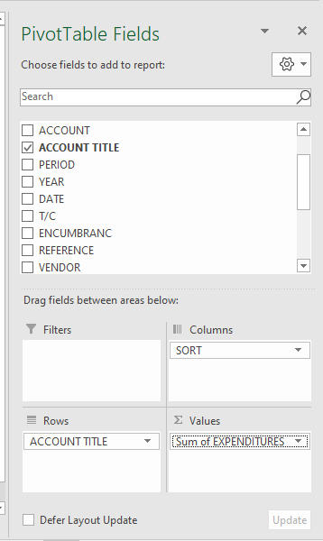
- Left click on the down facing arrow next to Sum of EXPENDITURES and select Value Field Settings.
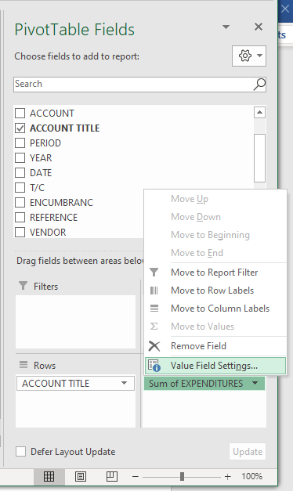
- In the Value Field Settings window, click on the Number Format box.
- Select “Currency” and click on the box for OK.
- Rename the worksheet “Other Cost SumQX”
- Rename “Row Labels” to “Account Title”
- Review the allocations of costs between the Cost Pools and Direct Charge Columns. A few things to look for include:
  - Most MEMBERSHIP expenditures should be allocated to CP 3 due to lobbying activities
  - All COST PLAN SRV A-87 expenditures should be allocated to CP 6
  - INTERFUND SRVCS to reimburse LGA Department for CMAA Administration and Coordination should be allocated to CP 3
  - Time Study Software Expenditures charged as PROFESSIONAL SERVICE expenditures should be allocated to Direct Charge.
Note: you can double click on any of the expenditure sums and a new worksheet will be created that shows the line item details for the sum.
- Navigate to the Page Layout tab, highlight the entire Pivot Table, click on the Print Area button, and select Set Print Area. Now, only your summary table with all the costs will show up in the back up documents.
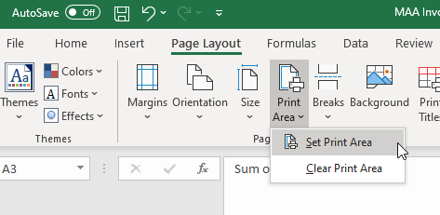
- To get the data needed to paste into the “Other Costs for Invoice” worksheet that will be included as back up with the CMAA invoice, highlight, copy, and paste the entire pivot table below the original one. You are going to filter out the expenses that don’t go into your “Other Cost for Invoice” worksheet (ex. Direct Charge Costs).
- In the copied Pivot Table, click on the Filter icon to the right of Column Labels and uncheck “Direct Charge”. Now your table only includes the expenses we want to include in this section of the CMAA invoice.

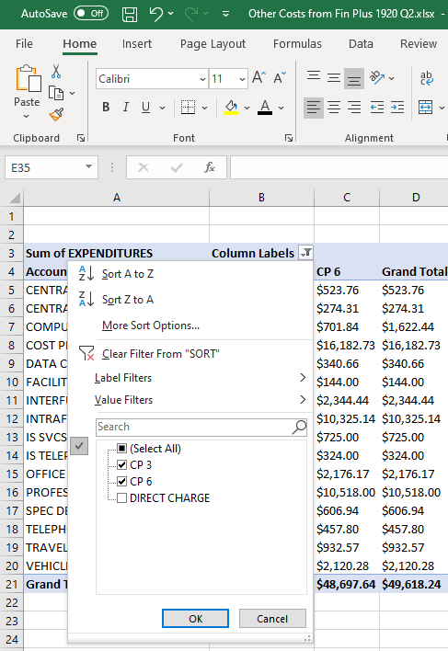

- Copy the expenditure data from the third row and down in your Pivot Table that only has Cost Pool 3 & 6 expenditures and paste this data into the table on the “Other Costs for Invoice” worksheet. This will copy the data, but not the actual pivot table which will give you an opportunity to make any final edits to the information.
- Copy your Notes for any expenditures (ex. Special Dept. Expenses, computers) into Column E of the “Other Costs for Invoice” worksheet.
- Worker’s Comp is charged once per year (usually in the first quarter) so you will need to run and save a separate Expenditure Transaction Report to capture Workers Comp expense.
  - Save an electronic copy of the report into the corresponding electronic invoice folder.
  - In your CMAA Invoice Workbook the “Other Costs for Invoice” worksheet, enter the total amount of Worker’s Comp Expenses charged in the quarter in Row 7 “for Account 510500– “WORKERS COMP INSURANCE”. The cost should be allocated to CP 6.
- You need to see if there are any prior year depreciation expenses to add in as well.
  - There should also be electronic copies of invoices for assets to depreciate saved in the electronic folder for the invoice you are working on.
  - If there are assets to add in to the invoice, enter the data into the “Computer.Equip Depreciation” worksheet in your CMAA invoice workbook for the quarter.
  - In the “Computer.Equip Depreciation” worksheet in your CMAA Invoice Workbook, clear the contents of the rows for purchases in other quarters – only include the rows for the current quarter.
  - You will need to insert a row in the “Other Costs for Invoice” worksheet in your CMAA invoice workbook for the quarter. Then enter the annual depreciation amount for Cost Pool 6 (1/3 of the original expense). Use a sum formula for the Grand Total as the total was pasted from the Pivot Table and will not update automatically. Can label this Account Description as “PRIOR YEAR”.

Direct Charge Worksheet

Non-Enhanced CMAA Personal Services CBO/Contractor Costs Section
Time Study Software expenses are currently included as a Direct Charge subcontractor in the CMAA invoice so you will need to find the amount of each invoice for the quarter that was directly charged to the Veterans Services Department.
- Run, download, and save in electronic invoice folder an Expenditure Transaction Analysis report from the financial system that shows the Time Study Software charges for the quarter.

- Make sure that you have copies of the Time Study Software invoices in the invoice folder.
- On the “Direct Charge” worksheet of your CMAA Invoice Workbook, update the months that match invoices received for the quarter. Clear the contents of the cells for each month of subcontractor expenses from the prior quarter.
- Input the dollar amount for each Time Study Software invoice that is charged to the Veterans Services Department into your CMAA Invoice Workbook “Direct Charge” worksheet and save.

CWA
State and federal guidelines require that the method used to determine the Medi-Cal percentage be “statistically valid.” There are two approved methods: actual client count and countywide average (CWA). Since we do not have a data sharing agreement with the Veterans Services Department to share their client data with us to submit through MOVEit, we use the Countywide Average for this Claiming Unit.
In order for LGAs participating in the CMAA Program to use the CWA, each claiming unit must annually submit a “Justification Letter” to DHCS on LGA letterhead, specifically stating the reason(s) why the claiming unit is unable to use the Actual Client Count (ACC), the required methodology from the CMAA Implementation Plan. The “Justification Letter” must be submitted to the LGA’s designated CMAA Program analyst via email before the start of the first quarter of the new fiscal year.
DHCS starts to release the countywide averages (via an email to the LGA Coordinators) in the fall after the fiscal year has ended. You will need to wait to submit your invoices for the completed fiscal year until the countywide average is released for each quarter.
Once released, save a copy of the DHCS CWA for the quarter in the corresponding electronic invoice folder.

Time Study Software Time Survey Data
These are instructions from one time study vendor. There are other software vendors available or some counties use their own timekeeping system. This is not a recommendation for one vendor over another but just showing how one county obtains the necessary time study roll-up data for CMAA invoicing.
In the CMAA Invoice Workbook, delete the worksheets from the previous quarter for “Percentages” and “TS Hours”.

Time Study Detail Hours Report
You need to find the total number of hours charged to each time study code for the Veterans Services Staff. In the Time Study Software:
- Select REPORTS from the ADMIN Menu drop down list.
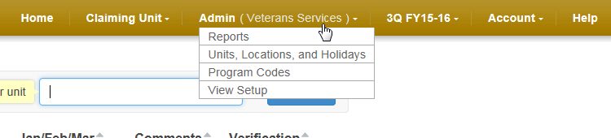
- Select Claim and Create New Batch
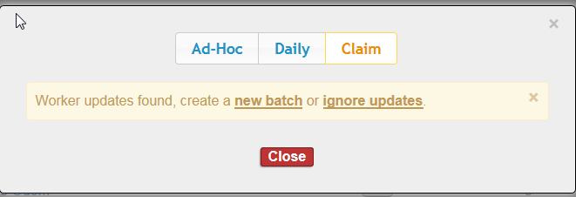
- Choose “Detail”
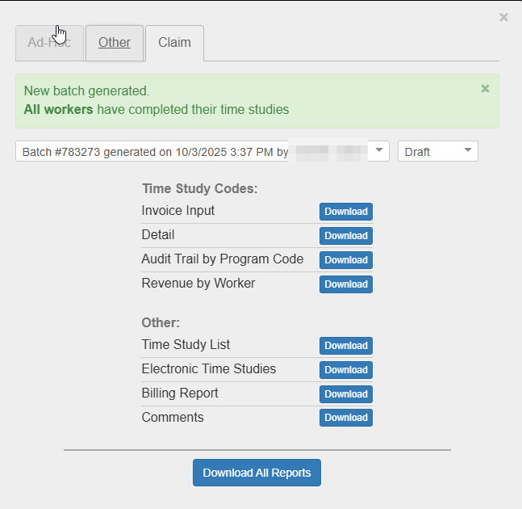

- Download Report.
- Open.
Copy the worksheet from Detail report and use the drop down menu to move selected sheet to your CMAA Invoice Workbook. Rename the worksheet “TS Hours.”
Navigate to Page Layout – Page Setup - format worksheet so that it is oriented to Landscape and can print on one page.
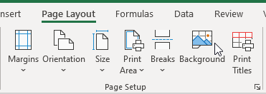
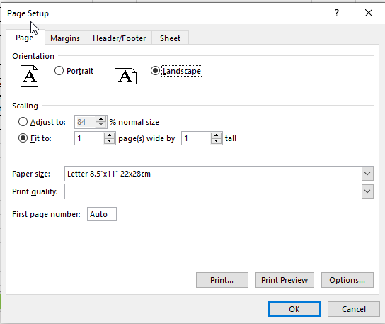
Save.

Time Study Invoice Input Report
Next, run a roll-up report in the Time Study Software that can easily be copied and pasted into the CMAA Invoice.
• Select REPORTS from the ADMIN Menu drop down list.
• Select CLAIM and create new batch.
• Choose “Invoice Input” from the list of Claim Reports.
• Click on “Download” button.
• Open.
Copy the worksheet from the Invoice Input Report and use the dropdown menu to move the selected sheet to your CMAA Invoice Workbook. Rename the worksheet “TS Percentages”.
If there are zero hours charged to any code ranging from 1-22, you need to input a zero in the blank cell in order to input the info easily into the CMAA invoice. You can do this by highlighting all of the cells missing a zero, use the Control F keyboard shortcut, go to the Replace worksheet, leave Find What: blank, Replace with: 0, and click on Replace All.
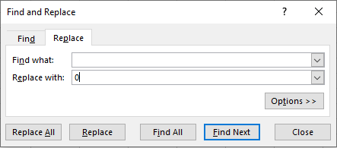
Navigate to Page Layout – Page Setup - format worksheet so that it is oriented to Portrait and can print on one page.
Save.

Completing the CMAA Invoice
The CMAA invoice contains very few fields where specific county/agency information is entered. The majority of the invoice is formula driven. The formula driven cells are locked in the invoice template.
In your CMAA invoice folder for the current FY and quarter, open the CMAA Invoice.

Invoice - Summary Page
Update as follows:
- Contract # (if necessary)
- Period of Service Dates for the quarter, ex. FY 19/20 Q1 would be 07/01/2019-09/30/2019
- Invoice Number (ex. for 1920 Q1 it would be “XX – XXXX – 1920 -1”) Note: XX is the LGA ID # and XXXX is the Claiming Unit ID #. These numbers are provided by our assigned CMAA Analyst.
- Printed Name of Signer and Title (if necessary) – this person should be the LGA Coordinator.
- Date Signed & Generated: Use the date you plan to sign the invoice.
- This page needs the Veterans Services letterhead to be added to the Header. In the CMAA Invoice, navigate to the Page Layout worksheet – Page Setup – Header/Footer – Custom Header – Place your cursor in the Center section – click on the icon for picture (Triangle in background) – Select Insert Pictures From a File – Select the letterhead saved as a JPEG.
- When you see, &[Picture] in the Center Section, click on the OK button.
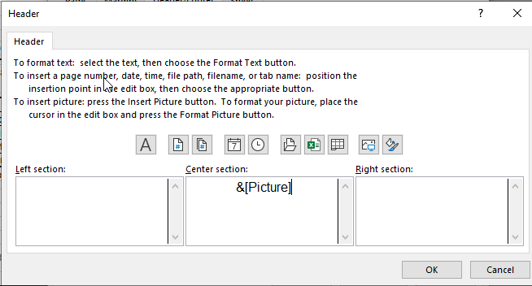

Invoice – T.S. Results Summary
- Open your CMAA Invoice Workbook to the “TS Percentages” worksheet and the CMAA Invoice to the “T.S. Results Summary” worksheet (need to have both documents open in Excel at same time in order to paste info).
- Copy the total number of hours for Veterans Services staff and “Paste Values” into Column J “Non-SPMP Total Hours” on the invoice. You will have to paste Codes 1-15, Code 17, and Codes 20-22 separately.
- Double check that your T.S. totals in your CMAA Invoice match the totals in your CMAA Invoice Workbook.
- Enter the countywide average Medi-Cal enrollment rate for the quarter into Column L “Medi-Cal %” for Codes 6, 10, 13, 17, and 18 (mint green). Or ACC if you are using the ACC.
- Make sure that CWA is selected in cells M11, M15, M18, M22, and M23. Or ACC if you are using the ACC.
- Make sure that the Time Survey Frequency Used to Determine the Activity Percentages: Perpetual.
- Enter the number of time study participants into the invoice. You can find the number of time study participants in your CMAA Invoice Workbook “Unit Staff” worksheet.
- Update Printed Name of Claiming Unit Reviewer, Classification Title, Printed Name of LGA Reviewer, and Classification Title (if necessary).
- Save.

Invoice – Revenue Worksheet
- You only need to complete this section once when you are finalizing the first quarter’s invoice for the FY. This is because the per quarter amount will be the same each quarter of the FY.
- If it doesn’t already say so, type “See Attached Revenue Worksheet” in cell A39 on the “Invoice – Revenues Worksheet”.
- Clear the contents of the cells C39, E39, F39, and I39 on the Invoice – Revenues Worksheet.
- Open your CMAA Invoice Workbook to the “Revenues for Invoice” worksheet.
- In your CMAA Workbook, find the total amount of Non Offset (Column H) and input this # into cell C39.
- In your CMAA Workbook, find the total amount of CP 2 (Column I) and input this # into cell E39.
- In your CMAA Workbook, find the total amount of CP 3 (Column J) and input this # into cell F39.
- Update “Printed Name of Signer” (if necessary).
- Double check totals.
- Ensure that you are correctly categorizing federal funds or county or state funds used to draw down federal funds as Offset. Remember that Offset funds are required to be reported on the CMAA invoice to ensure that you are not double claiming for FFP (ex. same expenses to CMAA and Medi-Cal Cost Avoidance Program).
- Save.

Invoice – Cost Worksheet
- In the CMAA Invoice “Invoice - Cost Worksheet” worksheet, clear the contents of the cells in Columns C through G.
- Open your CMAA Invoice Workbook to the “SalBenCalc for Invoice” worksheet.
- Input the corresponding Salary and Benefit amounts for each Cost Pool (2, 3, or 6) from Cells E29 – F30 into the CMAA Invoice – Cost Worksheet Rows 8 “Wages/Salary” and 9 “Benefits”/Columns D and E.
- Double check totals and Save.
- If it doesn’t already say so, type “See Other Costs Spreadsheet” in Cell A13.
- Open your CMAA Invoice Workbook to the “Other Costs for Invoice” worksheet. Input the corresponding Total Other Cost amounts for Cost Pool 3 into Cell E13 and Cost Pool 6 into G13 in the CMAA Invoice “Invoice – Cost Worksheet”.
- Update “Type or Print Name of Signer” (if necessary).
- Double check totals and save.

Invoice – Direct Charge Costs
- Open your CMAA Invoice Workbook to the “Direct Charge” worksheet.
- Open the CMAA Invoice “Invoice – Direct Charge Costs” worksheet.
- In the “Non-Enhanced CMAA Personal Services CBO/Contractor Costs” Section of the CMAA Invoice, input CBO/Contractor Name, Expense Detail (type of service contract), Code, and Pers. Svcs. Contract Costs for the quarter. See example below.
CBO/Contractor | Expense Detail | Code | Pers. Svcs. Contract Costs
Time Study Software | Time Study Software | 19 | Total $ amount from Direct Charge worksheet in CMAA Workbook

- Update Printed Name of Signer (if necessary).
- Double check totals and save.

Invoice – Claim Calculation
- Update “Type or Print Name of Signer” (if necessary) on pages 1 and 2.
- Everything else on this worksheet is automatically calculated based on data entered on other worksheets. However, on page 2, you should review the Total Federal Share Section to ensure that the invoice is “CPE Eligibility: Compliant” (meaning that the claiming unit has enough non-offset revenues to equal or exceed the amount of CMAA costs the unit is claiming). If the unit is not CPE Compliant, check the revenue worksheet to ensure all revenues were entered correctly. If the unit does not have enough non-offset revenues, the invoice will be automatically reduced to equal the amount of non-offset revenues available.
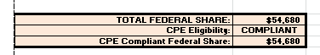

Invoice – 20% Variance
These two pages need our current department letterhead to be added to the Header.
In the CMAA Invoice, navigate to the Page Layout worksheet – Page Setup – Header/Footer – Custom Header – Place your cursor in the Center section – click on the icon for picture (Triangle in background) – Select Insert Pictures From a File – Select the letterhead saved as a JPEG.
When you see, &[Picture] in the Center Section, click on the OK button.
INVOICE PERCENTAGE VARIANCE
- You need to find the dollar amount invoiced for the Prior Year Corresponding Quarter and Prior Quarter. You can find this info in a CMAA Invoice Tracking spreadsheet (if you have one).
Look at the dollar amounts for the Prior Year Corresponding Quarter and Prior Quarter. Input the dollar amounts into your CMAA Invoice (Cells G-H17 and M-N17).
- If either variance exceeds 20%, you will need to include an explanation in the Variance section(s) below explaining the reason for the variance. In order to explain the variance, review the CMAA Invoice Tracking spreadsheet or prior invoices to determine what is different from the current invoice. For example, you may have significantly changed the number of staff who time study, time study results (as in claimable portion of time) may have changed significantly, or Other Costs may have increased.

ACTUAL CLIENT COUNT (ACC) PERCENTAGE VARIANCE
- You need to find the CWA (or ACC if using) percentage that was used in the invoice for the Prior Year Corresponding Quarter and Prior Quarter. You can find this info in a CMAA Invoice Tracking spreadsheet (if you have one) or prior invoices.
Look at the Medi-Cal percentage for the Prior Year Corresponding Quarter and Prior Quarter. Input these percentages into your CMAA Invoice (Cells G-H64 and M-N64). Link cells G-H65-68 to G-H64 so you only have to type the number once. Similarly, Link cells M-N65-68 to M-N64.
- If either variance exceeds 10%, you will need to include an explanation in the Variance Narrative(s) below explaining the reason for the variance. If you are using the CWA, it does not vary much so it’s unlikely you will have a variance greater than 10%. Just enter “N/A – Using CWA” in the variance explanation box.

Testing Scenarios to Increase Invoice Claimable Amount
Prepare the CMAA invoice first using all time study participants’ time survey results in order to have a baseline for comparing different scenarios. Review time study results. If a time study participant has less than 5% (or determine your own agency’s cut off) of reimbursable time (revenue percent), you will want to run your invoice with and without this person’s time survey results. If you exclude this person from your time study results, be sure to move his/her payroll costs to Cost Pool 3 as well. And, review supervisor and support relationships for staff claimed in the CMAA invoice. For example, to claim a supervisor’s time in Cost Pool 2, all of the staff he/she supervises must complete time studies that are included in the invoice calculation.
Note, when staff are on leave (ex. FMLA) for extended periods of time, it is usually more beneficial to include their time survey results and payroll costs even though all of their time is charged to Code 22.

Assembling the Invoice Package

Documents to include from the CMAA Invoice Workbook:
- You will need to save these supporting documents from the CMAA Invoice Workbook as a PDF and insert these pages after the relevant page in the CMAA Invoice as follows:
  - “Revenues – for Invoice” after “Invoice – Revenue Worksheet”
  - “SalBenCalc – for Invoice” and “Other Costs – for Invoice” after “Invoice – Cost Worksheet”
  - “Org Chart” last page of invoice document
- You should also insert the approved CUFG for the Fiscal Year and Quarter that corresponds to the invoice. This may speed up DHCS’s review of the invoice.

Invoice Checklist
- The invoice checklist is part of the CMAA Invoice Template. Navigate to the first worksheet in the CMAA invoice.
- Review the checklist. Once complete, check all of the boxes in Cells A14-A31.

Invoice Submission Memo
- Look at a copy of the “Invoice Submission Memo” in the invoice folder for the prior quarter or fiscal year. Save a copy into your current quarter invoice folder.
- Complete the memo with date uploaded to DHCS via Secure File Transfer Site (SFT), FY, Quarter, amount of invoice, and Date Sent to DHCS (upload date).
- Save as a PDF.

Double Check Documents
- Follow the instructions on the “Invoice Checklist” for what to check on your invoice.
- Also review the following and edit as necessary:
Invoice Page to | CMAA Invoice Workbook Worksheet
Invoice – T.S. Results Summary | TS Percentages
Invoice – T.S. Results Summary | CWA
Invoice – Revenue Worksheet | Revenues for Invoice
Invoice – Cost Worksheet | SalBenCalc for Invoice
Invoice – Cost Worksheet | Other Costs for Invoice
Invoice – Direct Charge Costs | Direct Charge

Invoice Package, Signatures, and Submission
You will submit two PDFs to DHCS: Signed invoice with all the backup worksheets and Invoice Submission Memo.
For the CMAA Invoice:
- Make sure the date is correctly entered on all of the CMAA Invoice worksheets.

- Save the file as a PDF. Make sure to Add All >> sheets and then click on the Convert to PDF button. The name for the new file will be ACB_VeteransServices_XXXX-X”. XXXX-X is the FY and Quarter such as 2223-1 for FY 22/23 Q1.

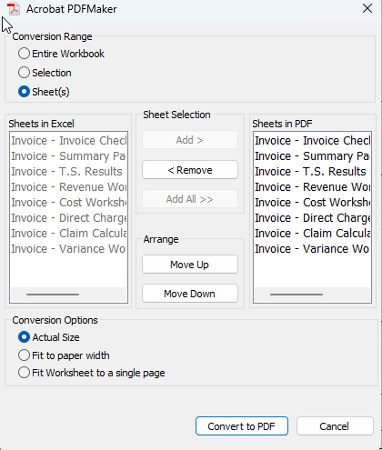

- In Adobe, insert all of the supporting documentation worksheets and approved CUFG for the quarter. Make sure everything looks correctly formatted (no extra pages).

- If you are not the LGA Coordinator, provide the PDF Invoice document to the LGA Coordinator for review and signature.

- The LGA Coordinator can sign in Adobe using these steps:
  - From the menu on the left, select Fill & Sign.
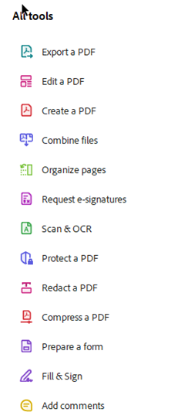
  - A signature is required on the following CMAA Invoice Pages:
    - “Invoice – Invoice Checklist” (3rd page)
    - “Invoice – Summary Page”
    - “Invoice – T.S. Results” (2x)
    - “Invoice – Revenue Worksheet”
    - “Invoice – Cost Worksheet”
    - “Invoice – Direct Charge Costs”
    - “Invoice – Claim Calculation” (2x)
    - “Invoice – Variance Worksheets” (2x)
The signed CMAA Invoice can now be uploaded to DHCS via their Secure File Transfer Site (SFT).
If you don’t have access, you can request access from your CMAA Analyst.
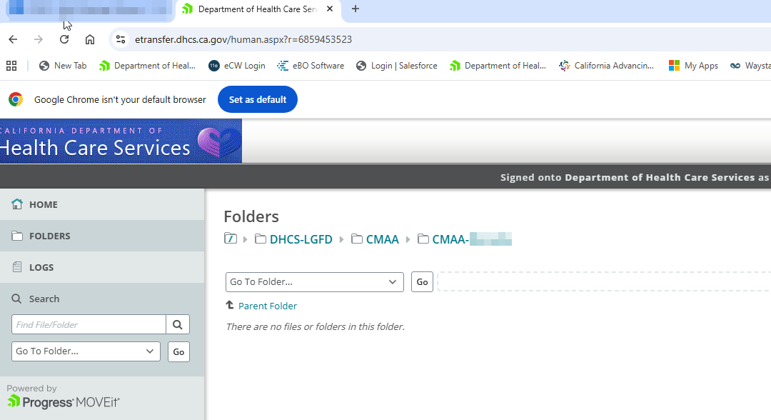
Within the SFT site, on the left side of the screen, select the invoice uploader folder using the down facing arrow to right and select: / DHCS-LGFD / CMAA / CMAA - ABC
You can drag files in to upload or use the teal Upload Files button.
Email your assigned DHCS Analyst and copy the CMAA Mailbox to notify them that you have uploaded a new invoice(s) for review. Include the “Invoice Submission Memo” as an attachment to your email. CMAA Mailbox: cmaa@dhcs.ca.gov
Sample Email Text:
“Hi ,
Just wanted to let you know that I uploaded ABC County’s – Veterans Services - FY 22/23 Q2 - Q4 Invoices to the DHCS SFT Site. Please see attached screenshot and Invoice Submission Memo and let me know if you have any questions. Thank you,”
Attach a screenshot from the SFT Site folder showing where you uploaded the invoices and add a box around the newly uploaded invoices.

And, attach the “Invoice Submission Memo”.

Save a copy of the email and the screenshot just in case you need to show later on that you submitted the invoice prior to its due date.

Update Accounts Receivable Log and CMAA Invoice Tracking Log
If your agency has an Accounts Receivable Log, update this after submitting an invoice.
If you are maintaining a “CMAA Invoice Tracking” spreadsheet, complete the row for the invoice you just completed.

Complete Audit File
To be ready for an audit, we prepare an Audit Ready File for each invoice so that we can easily share back up documents with DHCS. Within the corresponding CMAA invoice folder, create a subfolder called “Audit Ready Docs”. Within this folder, you will create and save the following PDF documents.
Note, you will need an Adobe Writer license to make combined PDFs as described below. Within Adobe, you will use the Organize Pages menu on the right. 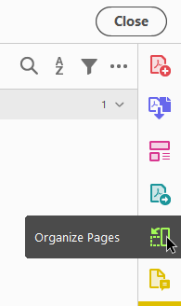
Once you create and save your PDFs, double check each one to be sure the formatting looks correct.
Audit File Documents and Names:
- “CWA - FY XXXX”
The email and spreadsheet come from DHCS via email to the LGA Coordinator.
- “Direct Charge – Subcontractor Costs – FY XXXX QX”
In the CMAA invoice workbook, select the “Direct Charge” worksheet and Save as an Adobe PDF into your “Audit Ready” folder. Then insert copies of the Expenditure Transaction Analysis report from the financial system, Time Study Software Invoices(s), and Time Study Software Invoice Back Up spreadsheet(s) that lists all staff in the claiming unit behind it.

- “Other Costs – FY XXXX QX”
In the CMAA invoice workbook, select the “Other Costs for Invoice”, “Other Cost SumQX”, and “Other Cost Detail QX” worksheets and save as an Adobe PDF into your “Audit Ready” folder (make sure all worksheets are added). Then insert copies of the Expenditure Transaction Analysis reports from the financial system behind it.

- “Other Costs – Prior Year Depreciation - FY XXXX QX” (If you are adding in equipment costs from prior years)
In the CMAA invoice workbook, select the “Computer.Equip Depreciation” worksheet and save as an Adobe PDF into your “Audit Ready” folder. Insert copies of the computer and other equipment invoices and corresponding financial system Transaction Analysis report showing the charge for the equipment.

- “Org Chart – FY XXXX QX”
Save a PDF copy of the Org Chart for the FY and quarter.
- “Payroll Costs – FY XXX QX”
In the CMAA invoice workbook, select the “SalBenCalc for Invoice”, “SalSumQX”, “SalariesQX”, “BenSumQX” and “BenefitsQX” worksheets and save as an Adobe PDF into your “Audit Ready” folder. Make sure all worksheets are added.

- “Revenues – FY XXXX”
In the CMAA invoice workbook, select the “Revenues for Invoice” worksheet and save as an Adobe PDF into your “Audit Ready” folder. Insert a copy of the Revenue Transaction Analysis Report after the Revenue spreadsheet and save.

- “TS Roll Up – FY XXXX QX”
In the CMAA invoice workbook, select the “Percentages” and “TS Hours” worksheets and save as an Adobe PDF into your “Audit Ready” folder.

- “TS Roster – FY XXXX QX”
In the CMAA invoice workbook, select the “Unit Staff” worksheet and save as an Adobe PDF into your “Audit Ready” folder.

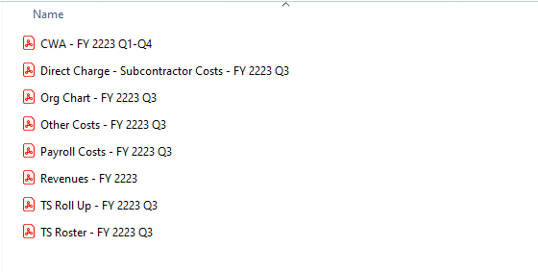

Revising or Correcting Invoices
You may realize at a later date that you need to correct or revise an invoice. If you are submitting a corrected invoice and the original has not been paid, it is a correction. If you’re submitting a corrected invoice after the original has been paid, then it is a revised invoice. The invoice number should be coded as (example for FY 19/20 Q1):
Correction: 29 – 1123 - 1920 – 1C
Revision: 29 – 1123 - 1920 – 1C
If you are correcting or revising for a second time, the last part would be “2C” instead of “1C”.

